HOW TO CHOOSE A STUDENT LEADERSHIP TEAM

OVERVIEW

Effective student leadership is essential to the success of your DECA chapter. Just like in business, it’s important to identify roles and responsibilities for key leaders that have a purpose in supporting the overall mission and goals of your DECA chapter. When developing your student leadership team, consider the functions of your DECA chapter and identify positions that will achieve those goals. DECA’s mission-based leadership positions reflect a corporate leadership structure. As emerging leaders, DECA encourages chapters to practice real-world leadership by adopting a structure that mirrors business and industry. DECA leadership positions are aligned with the DECA mission to ensure that each aspect of the mission is represented with great leadership. Depending on your chapter’s size, each leadership position can be developed into teams and committees to give more members opportunities to develop leadership abilities and engage in chapter activities.

SELECTION PROCESS

After you have identified the leadership positions within your chapter, you must then determine how you will select members to serve these key roles throughout the year. Both the advisor and the members should recognize the importance of choosing leaders who can effectively fulfill their responsibilities to grow the chapter and achieve its goals. You should consider the components that are important in a selection process and develop a clear, written description of how the selection process will be managed.

The process may include a combination of the following components:
- Written application, including qualifications, explanation of desire to serve and signatures of the student and parent supporting a code of conduct and performance expectations for the year. • Evaluations and statements of support completed by teachers or community members.
- Interview with a panel of alumni and businesspeople.
- Written exam on DECA knowledge, leadership and course content.
- Vote based on an anonymous written paragraph on why the candidate wishes to serve.

It is important to avoid an election process that resembles a popularity contest in which leaders are elected with little or no consideration given to leadership characteristics. Although it is important for students to be involved in the selection process, the actual vote may count toward a portion of the overall decision. In that regard, it is also important to help members understand the qualities of leaders, the commitment the leaders must make and the roles and responsibilities of those elected.
THE TEAM STRUCTURE

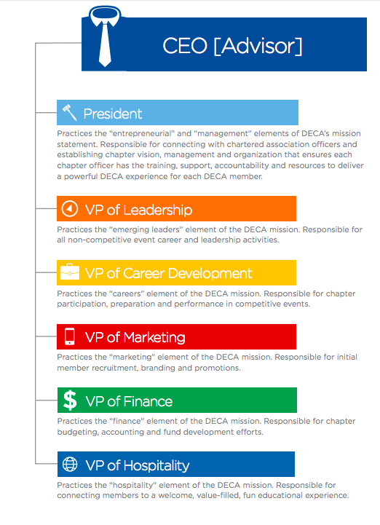
SAMPLE INTERVIEW QUESTIONS
Through either an interview process or a written essay, you may ask candidates vying for a position on the chapter leadership team to respond to the following questions:

- Which guiding principle of the DECA Diamond is important to you and why?
- What makes a good leader?
- Do you feel you have a special quality that helps in achieving your goals?
- Do you have any personal/business obligations that may hinder your performance as a member of the chapter leadership team?
- How do you generate energy and enthusiasm in people?
- What difference do you see in yourself when you’re in a leadership position?
- What is your definition of success?
- What person in your life has been most influential to you?
- What three things in your life are most important to you?
- What are your goals in the next five years?
- What is the biggest challenge facing DECA?
- If you could be any leader in the world, who would you be and why?
- A friend has worked on a project for DECA’s competitive events and asks you to read it. You think it needs much improvement. What do you say?
- If you could present the world with one gift, what would it be?
- How would you describe your leadership style?
- What is the most important quality a leader should possess?
- If you knew that today was the last day of your life what would you do?

AFTER ELECTIONS

PROGRAM OF LEADERSHIP

The DECA Program of Leadership brings together the leadership team, DECA goals and action items for the year into one strategic leadership plan. The program of leadership provides a comprehensive plan of the chapter’s goals and activities for the school year. Each goal is aligned with a mission area, assigns overall responsibility to a leader and indicates the key project initiatives, success criteria, time frame and project leaders.

DECA GOALS: D.E.C.A.

Goals provide a menu of suggested DECA chapter activities from DECA’s Comprehensive Learning Program. DECA Goals reflect a corporate style of goal setting that assigns a goal range or “targets” that everyone strives to achieve. Setting ranges of success for goals helps define the “baseline” expectation as well as the next progressive levels of success the chapter aims to achieve.

The four levels are as follows:

- Duty - This is the minimally acceptable and relatively easy level of success for your chapter.
- Exceptional - This level can be reached if the chapter is really organized, committed and well trained.
- Champion - This level is thought of as the “best in class,” representing extraordinary leadership.
- Actual - This column is used to record current and final progress.

Thank you to DECA Inc for the amazing tips and resources used to create this guide!

More information can be found by visiting https://www.deca.org/high-school-programs/emerging-leader-series/elevate/

